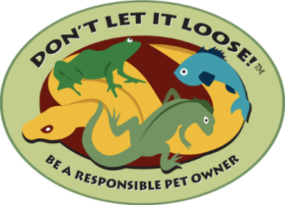

Dear Educator
Thank you so much for your interest in the Don’t Let it Loose program. To introduce concepts on invasive species, responsible pet ownership and rehoming pets instead of release for your classroom, you will find links to the following materials at www.dontletitloose.com/resources.
Linked Materials:
- Don’t Let it Loose poster to display in the classroom
- Don’t Let it Loose classroom pledge for all students to sign
- Don’t Let it Loose bookmarks for each student
- Don’t Let it Loose rack card
- Don’t Let it Loose Dodgeball activity guideline
So now what?
Teaching about the idea that invasive species introduction can be linked to pet and aquarium release is key to our program. We have created a short video that would be good for either you or the entire class (depending on the age group) to watch. The video can be found here: https://stopais.org/education/dont_let_it_loose/
The idea of being a responsible pet owner has great connections to classroom concepts even if you do not have a pet in the classroom. Many families of course have pets at home and sharing ideas about who must feed, water, play with, walk and clean up after pets is great. The idea of rehoming pets is really one of community. The principles of community that you create in your classroom with respect for each other and responsibility for classroom duties are an extension of this concept. Rehoming pets means reaching out to a shelter, a friend or a neighbor that might be able to help. Next, here is where the big idea of invasive species comes – never release a pet, or aquarium contents. Releasing a pet is not humane. Some pets or plants can become invasive species under the right conditions. Signing the pledge together as a classroom is a really powerful way to create accountability and agreement this concept. Try displaying the completed pledge near any classroom pet habitats or aquariums if you have them.
There are many resources out there on invasive species, you can check out what we have on our website (www.stopais.org) as a start. If you think your fellow teachers would also have an interest in the packet materials, please connect us! Reach out with any suggestions to improve this project – we love feedback. Thank you for helping to promote rehoming of pets and responsible pet ownership.

Resources to incorporate Don’t Let it Loose in the Classroom
Don’t Let it Loose in the Classroom - https://youtu.be/IXlnj-LWkOk This is an ISAN created narrated power point talking about the basic concepts of responsible pet ownership, not releasing pets to prevent the introduction of invasive species and the impacts from those pet releases.
Take a Bite Out of Bullfrogs - https://youtu.be/BciE0_E5FpI This is a short ISAN created cartoon that focuses on bullfrogs, a common pet, that can cause problems when released.
Don’t Let it Loose to protect our Montana Native Wildlife – https://www.kpax.com/brand-spotlight/montana-fish-wildlife-parks/dont-let-it-loose This is a short Montana Fish Wildlife & Parks created video that encourages protecting our wildlife with Don’t Let it Loose ideas.
Montana Native Species - https://www.kpax.com/brand-spotlight/montana-fish-wildlife-parks/montana-native-species This is a short Montana Fish, Wildlife & Parks created video that focuses on native wildlife of Montana and ties to Don’t Let it Loose.

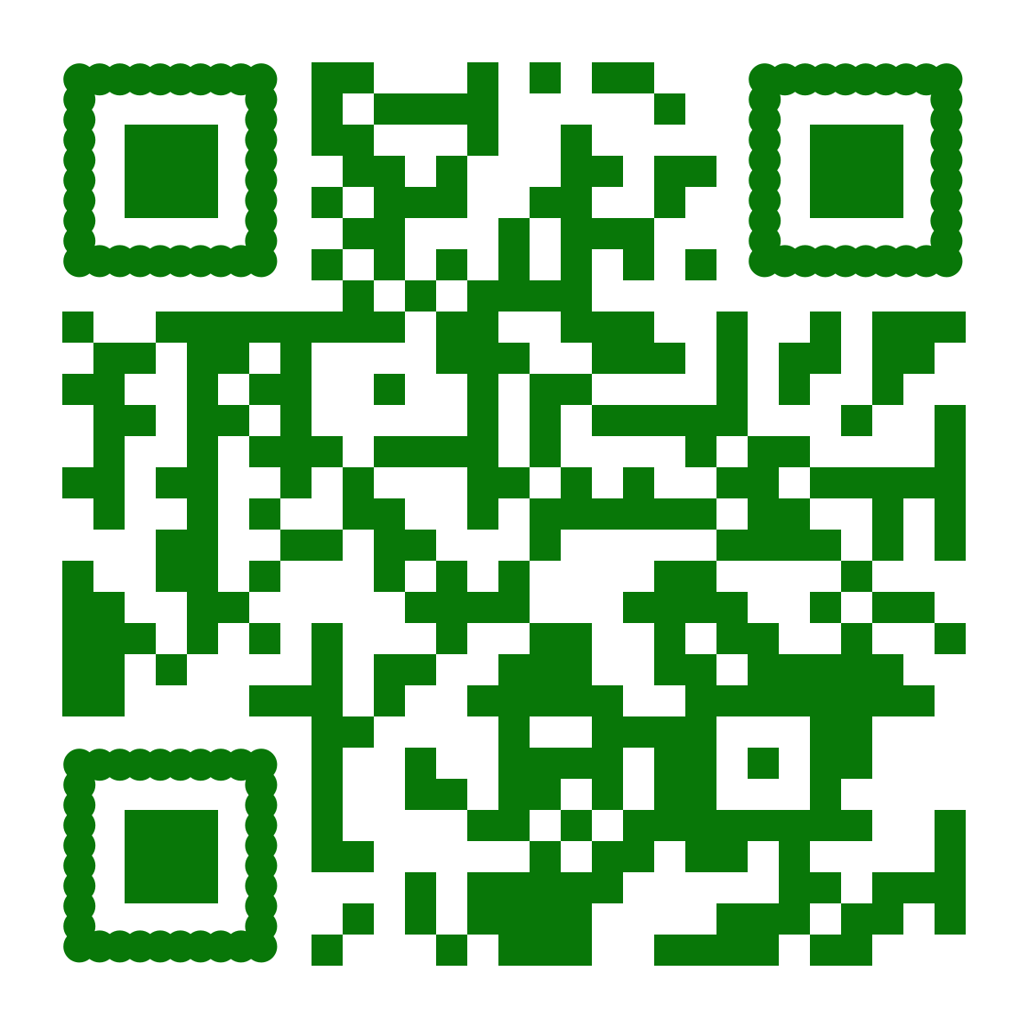
Thank you so much for teaching our materials in your classroom! Please help us improve our materials and expand our reach by following the QR code to take a quick survey. The survey will take you approx. 4 minutes to complete and will greatly help our efforts.
Sincerely,
The Team at Invasive Species Action Network
Email: info@stopais.org
Website: www.stopais.org
Phone: 406-222-7270
Livingston, MT

** This project is a collaboration between Montana Fish, Wildlife & Parks and is supported by the Montana Invasive Species Council. **

